VERDE VALLEY PIONEERS
Biography Information Form
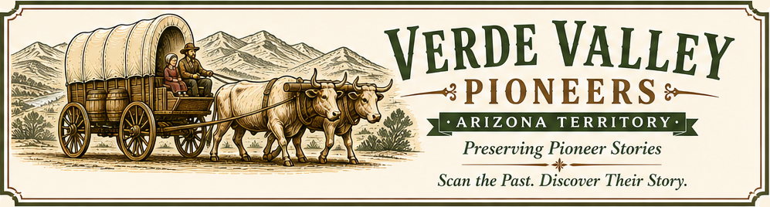
Preserving the stories of Verde Valley pioneers for future generations.
VVP – Biography Information Form
Revision 2.1 – July 2026
Instructions
Thank you for helping preserve the history of a Verde Valley Pioneer. Complete as much of this form as possible. Leave unknown items blank. Attach one or two photographs if available. Portrait photographs are especially helpful. Family photographs, homes, businesses, ranches, military service, gravesites, and other historical images are also welcome. Email the completed form and attachments to info@VerdeValleyPioneers.com.
After reviewing your submission, a Verde Valley Pioneers volunteer will prepare a publication-ready biography using the Verde Valley Pioneers Biography Builder. We may contact you if additional information or clarification is needed before publication.
Your Contact Information
Your Name
Email Address
Relationship to the Pioneer

Pioneer Information
Full Name (include maiden name if applicable):
Birth Date
Birth Place
Death Date
Death Place
Cemetery / Grave Location
Parents (names only if dates are unknown)
Spouse(s) (names only if dates are unknown)
Children (names only if dates are unknown)
Siblings (names only if dates are unknown)

Life Story
Education
Occupation
Military Service
Organizations
Community Involvement (church, civic clubs, volunteer work, offices held)
Accomplishments

Pioneer Heritage How did this person become part of Verde Valley history?
Arrival in Verde Valley
How they arrived
When and where did they live in the Verde Valley

Biography Information
What would you like future generations to know about this person?
Stories, memories or interesting facts:

Did we miss anything?

Have you found any websites or online resources about this pioneer?
If so, please copy and paste the website addresses (URLs) below. These links help us locate and verify information while preparing the biography. Website links help us verify historical facts and may lead us to additional photographs and records. If a resource requires a subscription or login (such as Ancestry), please also summarize the information or upload copies of any important records or photographs.
Examples include:

- Verde Independent article
- Sharlot Hall
- Newspapers.com
- Facebook posts or pages
- Family websites
- Historical society websites
- Genealogy websites
  - Find a Grave
  - Family Search
  - Ancestry
- History websites
- Archives.gov

Website Addresses (URLs):

Permission to Publish
By submitting this completed form and any supporting materials to info@VerdeValleyPioneers.com, you confirm that:
- The information is accurate to the best of your knowledge.
- You have permission to share the submitted photographs, documents, and materials, or you own the rights to them.
- You grant Verde Valley Pioneers (VerdeValleyPioneers.com) permission to edit, organize, and publish the submitted materials as part of the Verde Valley Pioneers Archive, website, and related educational publications.
- You understand that we may contact you if additional information or clarification is needed before publication.
You will retain ownership of your original photographs and documents. By submitting them, you grant Verde Valley Pioneers permission to reproduce them in connection with this project.
Your Name:
Date:

Return Instructions
How to Submit
- Complete this form.
- Email the completed form to info@VerdeValleyPioneers.com.
- Send photographs and documents as attachments in the same email or in a second email immediately afterward.

Additional Materials
Do you have any additional materials that may help us prepare this biography?
Items that you can send as an email attachment? Send a second email if needed.
Examples include:

- Letters
- Diaries or Journals
- Marriage Certificate
- Birth/Death Certificate
- Military Records
- Land Records or Deeds
- Homestead Records
- Military Pension Application
- Obituary
- Newspaper Articles or Clippings
- Family Photographs
- Cemetery Photographs
- Maps
- Audio Recordings
- Video Recordings
- Oral Family Histories
- Scrapbooks
- School Records or Yearbooks
- Church Records
- Business Records
- Family Trees or Genealogy Charts
- Other Historical Documents

Attachments
To help us process your submission as quickly as possible, please send photographs and documents in one of these common file formats:
Accepted file formats:
- PDF (.pdf)
- JPEG Photo (.jpg, .jpeg)
- PNG Image (.png)
- Word Document (.docx)
- Text File (.txt)
For your protection and ours,
please do not send executable or program files. The following file types will not be accepted:
- .exe
- .bat
- .cmd
- .com
- .scr
- .js
- .vbs
- .msi
- .ps1
To help protect our computers and volunteers from malicious software, executable and program files cannot be accepted.

